**Motion Triggered Image Capture and Email**

I am building a motion-triggered image capturing system that also sends an email with the image as an attachment once an intruder is detected.

**Things used in this project**

ESP32-camera

PIR sensor (generic)

Power Jack

9v battery and connector

1kohm and 10kohm resistors, NPN transistor (2N3904)

Header Pins

Switch

Potentiometer and KA317 voltage regulator

Wires, soldering and copper through hole PCB

**Step 1: Gather the Electronics**

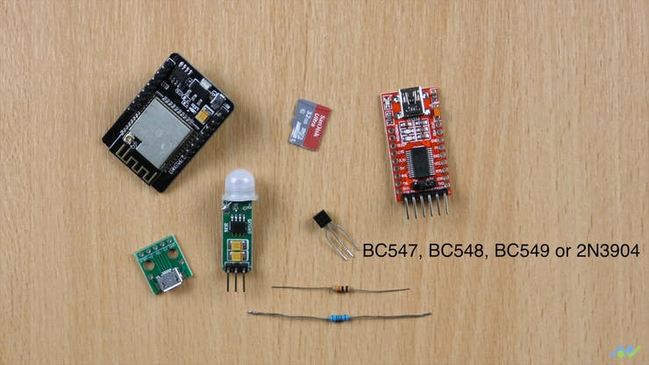

**Schematics**

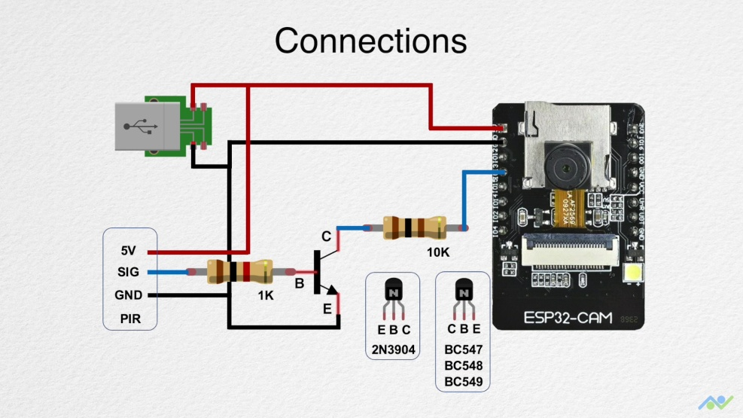

**Story**

With the alarming rate of insecurity and theft, building a motion detection system deemed fit for a system to help improve security and ensue privacy. Hence, the initiative of a ‘motion-triggered image capturing system’ was born.

We build upon the ESP32-CAM board and a PIR sensor module to build a motion-triggered image capturing system that also sends an email with the image as an attachment. The board spends most of the time in sleep mode and wakes up to take an image once motion is detected. Here’s a block diagram of the working of the system.

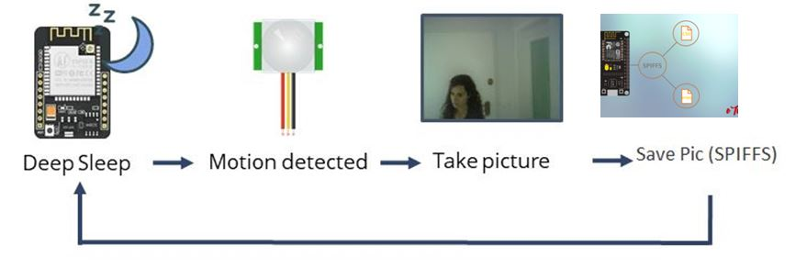

Once motion is detected, it takes the picture of the intruder or whatever, saves it on the file memory system of the board called SPIFFs, then using STMP protocols, it sends the image to a designated mail.